**Hibernate Inheritance Mapping**

We can map the inheritance hierarchy classes with the table of the database. There are three inheritance mapping strategies defined in the hibernate:

1. Table Per Hierarchy
2. Table Per Concrete class
3. Table Per Subclass

Hibernate Table Per Hierarchy using Annotation

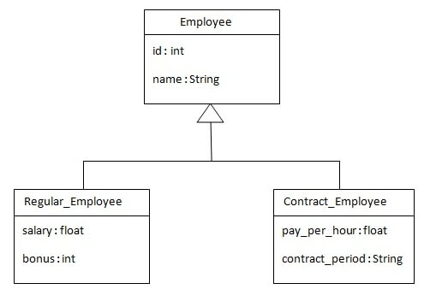

|  |
| --- |
| The table structure for this hierarchy is as shown below: |

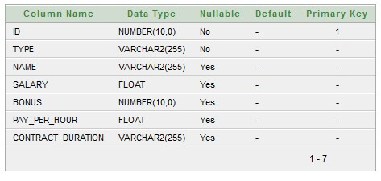

### **Example of Hibernate Table Per Hierarchy using Annotation**

You need to follow the following steps to create simple example:

* Create the persistent classes
* Edit pom.xml file
* Create the configuration file
* Create the class to store the fetch the data

### **1) Create the Persistent classes**

You need to create the persistent classes representing the inheritance. Let's create the three classes for the above hierarchy:

***File: Employee.java***

**package** com.javatpoint.mypackage;

**import** javax.persistence.*;

@Entity

@Table(name = "employee101")

@Inheritance(strategy=InheritanceType.SINGLE_TABLE)

@DiscriminatorColumn(name="type",discriminatorType=DiscriminatorType.STRING)

@DiscriminatorValue(value="employee")

**public** **class** Employee {

@Id

@GeneratedValue(strategy=GenerationType.AUTO)

@Column(name = "id")

**private** **int** id;

@Column(name = "name")

**private** String name;

//setters and getters

}

*File: Regular_Employee.java*

**package** com.javatpoint.mypackage;

**import** javax.persistence.*;

@Entity

@DiscriminatorValue("regularemployee")

**public** **class** Regular_Employee **extends** Employee{

@Column(name="salary")

**private** **float** salary;

@Column(name="bonus")

**private** **int** bonus;

//setters and getters

}

*File: Contract_Employee.java*

**package** com.javatpoint.mypackage;

**import** javax.persistence.Column;

**import** javax.persistence.DiscriminatorValue;

**import** javax.persistence.Entity;

@Entity

@DiscriminatorValue("contractemployee")

**public** **class** Contract_Employee **extends** Employee{

    @Column(name="pay_per_hour")

**private** **float** pay_per_hour;

    @Column(name="contract_duration")

**private** String contract_duration;

    //setters and getters

}

### **2) Add project information and configuration in pom.xml file.**

Open pom.xml file and click source. Now, add the below dependencies between <dependencies>....</dependencies> tag.

<dependency>

    <groupId>org.hibernate</groupId>

    <artifactId>hibernate-core</artifactId>

    <version>5.3.1.Final</version>

</dependency>

<dependency>

    <groupId>com.oracle</groupId>

    <artifactId>ojdbc14</artifactId>

    <version>10.2.0.4.0</version>

</dependency>

### **3) Add the persistent classes in configuration file**

|  |
| --- |
| Open the **hibernate.cgf.xml** file, and add entries of entity classes like this: |

<?xml version="1.0" encoding="UTF-8"?>

<!DOCTYPE hibernate-configuration PUBLIC

        "-//Hibernate/Hibernate Configuration DTD 5.3//EN"

        "http://www.hibernate.org/dtd/hibernate-configuration-5.3.dtd">

<hibernate-configuration>

    <session-factory>

    <property name="hbm2ddl.auto">update</property>

        <property name="dialect">org.hibernate.dialect.Oracle9Dialect</property>

        <property name="connection.url">jdbc:oracle:thin:@localhost:1521:xe</property>

        <property name="connection.username">system</property>

        <property name="connection.password">jtp</property>

        <property name="connection.driver_class">oracle.jdbc.driver.OracleDriver</property>

        <mapping **class**="com.javatpoint.mypackage.Employee"/>

        <mapping **class**="com.javatpoint.mypackage.Regular_Employee"/>

        <mapping **class**="com.javatpoint.mypackage.Contract_Employee"/>

    </session-factory>

</hibernate-configuration>

The hbm2ddl.auto property is defined for creating automatic table in the database.

### **4) Create the class that stores the persistent object**

In this class, we are simply storing the employee objects in the database.

***File: StoreTest.java***

**package** com.javatpoint.mypackage;

**import** org.hibernate.Session;

**import** org.hibernate.SessionFactory;

**import** org.hibernate.Transaction;

**import** org.hibernate.boot.Metadata;

**import** org.hibernate.boot.MetadataSources;

**import** org.hibernate.boot.registry.StandardServiceRegistry;

**import** org.hibernate.boot.registry.StandardServiceRegistryBuilder;

**public** **class** StoreTest {

**public** **static** **void** main(String args[])

    {

        StandardServiceRegistry ssr = **new** StandardServiceRegistryBuilder().configure("hibernate.cfg.xml").build();

        Metadata meta = **new** MetadataSources(ssr).getMetadataBuilder().build();

        SessionFactory factory=meta.getSessionFactoryBuilder().build();

        Session session=factory.openSession();

         Transaction t=session.beginTransaction();

            Employee e1=**new** Employee();

            e1.setName("Gaurav Chawla");

            Regular_Employee e2=**new** Regular_Employee();

            e2.setName("Vivek Kumar");

            e2.setSalary(50000);

            e2.setBonus(5);

            Contract_Employee e3=**new** Contract_Employee();

            e3.setName("Arjun Kumar");

            e3.setPay_per_hour(1000);

            e3.setContract_duration("15 hours");

            session.persist(e1);

            session.persist(e2);

            session.persist(e3);

            t.commit();

            session.close();

            System.out.println("success");

    }

}

#### **Output:**

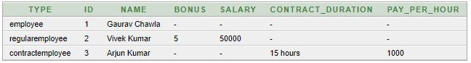

# Hibernate Table Per Hierarchy using xml file

### **Create the mapping file for Persistent class**

The mapping has been discussed above for the hierarchy.

***File: employee.hbm.xml***

<?xml version='1.0' encoding='UTF-8'?>

<!DOCTYPE hibernate-mapping PUBLIC

          "-//Hibernate/Hibernate Mapping DTD 5.3//EN"

          "http://hibernate.sourceforge.net/hibernate-mapping-5.3.dtd">

<hibernate-mapping>

<**class** name="com.javatpoint.mypackage.Employee" table="emp121" discriminator-value="emp">

<id name="id">

<generator **class**="increment"></generator>

</id>

<discriminator column="type" type="string"></discriminator>

<property name="name"></property>

<subclass name="com.javatpoint.mypackage.Regular_Employee" discriminator-value="reg_emp">

<property name="salary"></property>

<property name="bonus"></property>

</subclass>

<subclass name="com.javatpoint.mypackage.Contract_Employee" discriminator-value="con_emp">

<property name="pay_per_hour"></property>

<property name="contract_duration"></property>

</subclass>

</**class**>

</hibernate-mapping>

### **Add mapping of hbm file in configuration file**

Open the hibernate.cgf.xml file, and add an entry of mapping resource like this:

<mapping resource="employee.hbm.xml"/>

|  |
| --- |
| Table Per Concrete class using Annotation The table structure for each table will be as follows: |

#### **Table structure for Employee class**

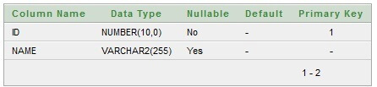

#### **Table structure for Regular_Employee class**

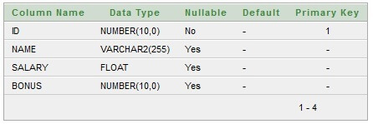

#### **Table structure for Contract_Employee class**

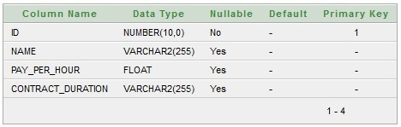

### **Create the Persistent classes**

You need to create the persistent classes representing the inheritance. Let's create the three classes for the above hierarchy:

***File: Employee.java***

**package** com.javatpoint.mypackage;

**import** javax.persistence.*;

@Entity

@Table(name = "employee102")

@Inheritance(strategy = InheritanceType.TABLE_PER_CLASS)

**public** **class** Employee {

@Id

@GeneratedValue(strategy=GenerationType.AUTO)

@Column(name = "id")

**private** **int** id;

@Column(name = "name")

**private** String name;

//setters and getters

}

***File: Regular_Employee.java***

**package** com.javatpoint.mypackage;

**import** javax.persistence.*;

@Entity

@Table(name="regularemployee102")

@AttributeOverrides({

    @AttributeOverride(name="id", column=@Column(name="id")),

    @AttributeOverride(name="name", column=@Column(name="name"))

})

**public** **class** Regular_Employee **extends** Employee{

@Column(name="salary")

**private** **float** salary;

@Column(name="bonus")

**private** **int** bonus;

//setters and getters

}

***File: Contract_Employee.java***

**package** com.javatpoint.mypackage;

**import** javax.persistence.*;

@Entity

@Table(name="contractemployee102")

@AttributeOverrides({

    @AttributeOverride(name="id", column=@Column(name="id")),

    @AttributeOverride(name="name", column=@Column(name="name"))

})

**public** **class** Contract_Employee **extends** Employee{

    @Column(name="pay_per_hour")

**private** **float** pay_per_hour;

    @Column(name="contract_duration")

**private** String contract_duration;

**public** **float** getPay_per_hour() {

**return** pay_per_hour;

    }

**public** **void** setPay_per_hour(**float** payPerHour) {

        pay_per_hour = payPerHour;

    }

**public** String getContract_duration() {

**return** contract_duration;

    }

**public** **void** setContract_duration(String contractDuration) {

        contract_duration = contractDuration;

    }

}

# Table Per Concrete class using xml file

### **Create the mapping file for Persistent class**

The mapping has been discussed above for the hierarchy.

***File: employee.hbm.xml***

<?xml version='1.0' encoding='UTF-8'?>

<!DOCTYPE hibernate-mapping PUBLIC

          "-//Hibernate/Hibernate Mapping DTD 5.3//EN"

          "http://hibernate.sourceforge.net/hibernate-mapping-5.3.dtd">

  <hibernate-mapping>

  <**class** name="com.javatpoint.mypackage.Employee" table="emp122">

  <id name="id">

  <generator **class**="increment"></generator>

  </id>

  <property name="name"></property>

  <union-subclass name="com.javatpoint.mypackage.Regular_Employee" table="regemp122">

  <property name="salary"></property>

  <property name="bonus"></property>

  </union-subclass>

  <union-subclass name="com.javatpoint.mypackage.Contract_Employee" table="contemp122">

  <property name="pay_per_hour"></property>

  <property name="contract_duration"></property>

  </union-subclass>

  </**class**>

  </hibernate-mapping>

### **Add mapping of hbm file in configuration file**

Open the hibernate.cgf.xml file, and add an entry of mapping resource like this:

<mapping resource="employee.hbm.xml"/>

# Table Per Subclass using Annotation

#### **Table structure for Employee class**



#### **Table structure for Regular_Employee class**

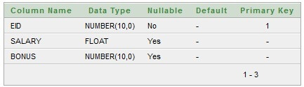

#### **Table structure for Contract_Employee class**

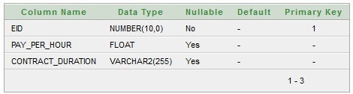

### **Create the Persistent classes**

You need to create the persistent classes representing the inheritance. Let's create the three classes for the above hierarchy:

***File: Employee.java***

**package** com.javatpoint.mypackage;

**import** javax.persistence.*;

@Entity

@Table(name = "employee103")

@Inheritance(strategy=InheritanceType.JOINED)

**public** **class** Employee {

@Id

@GeneratedValue(strategy=GenerationType.AUTO)

@Column(name = "id")

**private** **int** id;

@Column(name = "name")

**private** String name;

//setters and getters

}

***File: Regular_Employee.java***

**package** com.javatpoint.mypackage;

**import** javax.persistence.*;

@Entity

@Table(name="regularemployee103")

@PrimaryKeyJoinColumn(name="ID")

**public** **class** Regular_Employee **extends** Employee{

@Column(name="salary")

**private** **float** salary;

@Column(name="bonus")

**private** **int** bonus;

//setters and getters

}

***File: Contract_Employee.java***

**package** com.javatpoint.mypackage;

**import** javax.persistence.*;

@Entity

@Table(name="contractemployee103")

@PrimaryKeyJoinColumn(name="ID")

**public** **class** Contract_Employee **extends** Employee{

    @Column(name="pay_per_hour")

**private** **float** pay_per_hour;

    @Column(name="contract_duration")

**private** String contract_duration;

    //setters and getters

}

### **Create the mapping file for Persistent class**

The mapping has been discussed above for the hierarchy.

***File: employee.hbm.xml***

<?xml version='1.0' encoding='UTF-8'?>

<!DOCTYPE hibernate-mapping PUBLIC

  "-//Hibernate/Hibernate Mapping DTD 5.3//EN"

  "http://hibernate.sourceforge.net/hibernate-mapping-5.3.dtd">

  <hibernate-mapping>

  <**class** name="com.javatpoint.mypackage.Employee" table="emp123">

  <id name="id">

  <generator **class**="increment"></generator>

  </id>

  <property name="name"></property>

  <joined-subclass name="com.javatpoint.mypackage.Regular_Employee" table="regemp123">

  <key column="eid"></key>

  <property name="salary"></property>

  <property name="bonus"></property>

  </joined-subclass>

  <joined-subclass name="com.javatpoint.mypackage.Contract_Employee" table="contemp123">

  <key column="eid"></key>

  <property name="pay_per_hour"></property>

  <property name="contract_duration"></property>

  </joined-subclass>

  </**class**>

  </hibernate-mapping>

### **create configuration file**

Open the hibernate.cgf.xml file, and add an entry of mapping resource like this:

<mapping resource="employee.hbm.xml"/>